SPHU0 Combo Dynamics Problems.....Just do it!!! Date: ________

1.Two blocks, connected by a massless string, hang over a pulley that connects two inclines. When released, the blocks begin to move in the direction indicated. Block m₁ is 8.0 kg and block m₂ is 12.0 kg. There is a force of kinetic friction of 14.8 N acting on block 1 and a force of kinetic friction of 19.2 N acting on block 2.

Determine: a) The acceleration of the blocks. [ ans: 0.28 m/s²]
b) The tension in the string. [51 N]
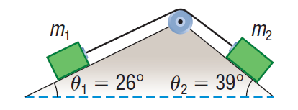
a

SPHU0 Combo Dynamics Problems.....Just do it!!! Date: ________

1.Two blocks, connected by a massless string, hang over a pulley that connects two inclines. When released, the blocks begin to move in the direction indicated. Block m₁ is 8.0 kg and block m₂ is 12.0 kg. There is a force of kinetic friction of 14.8 N acting on block 1 and a force of kinetic friction of 19.2 N acting on block 2.

Determine: a) The acceleration of the blocks. [ ans: 0.28 m/s²]
b) The tension in the string. [51 N]
a

